Steps to create BDC recording for XD01

1. Go to SE38.Create a report with the below code. 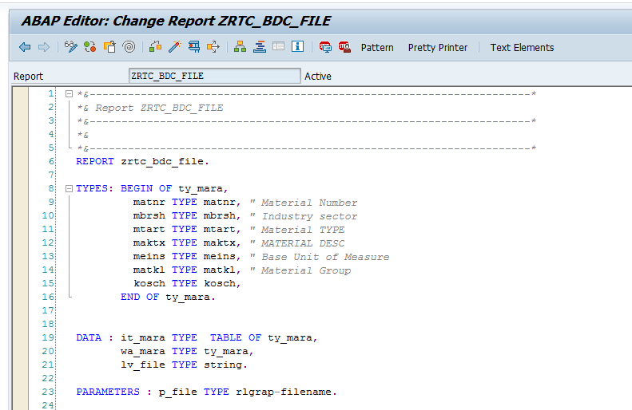

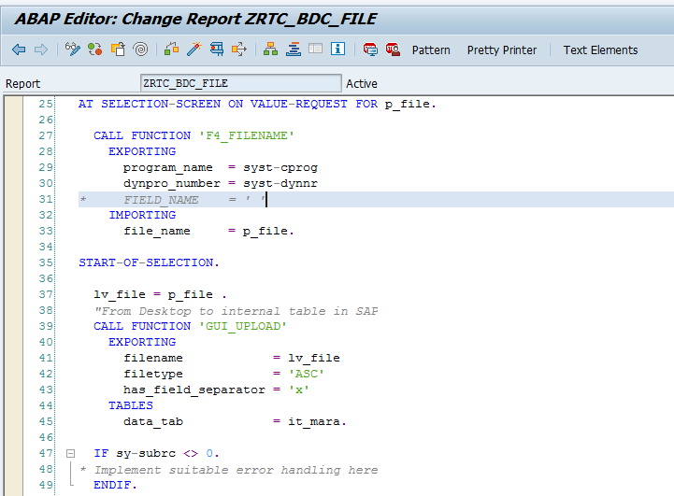

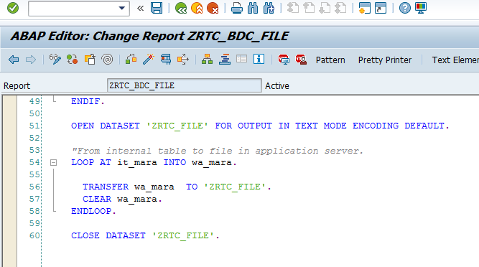

1. Create a text file with following data

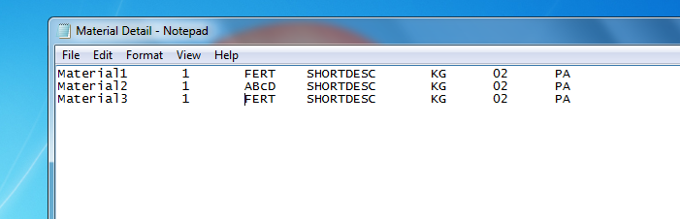

1. Save the file Material.txt on your local machines Desktop.

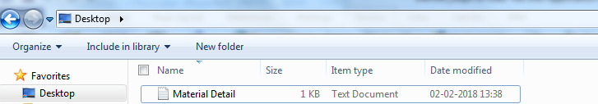

1. Execute the Report created in SE38

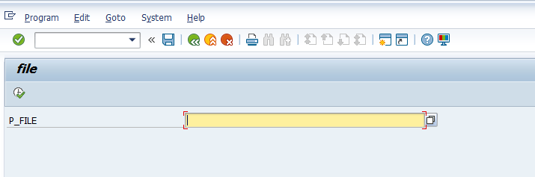

1. Click F4 and choose the file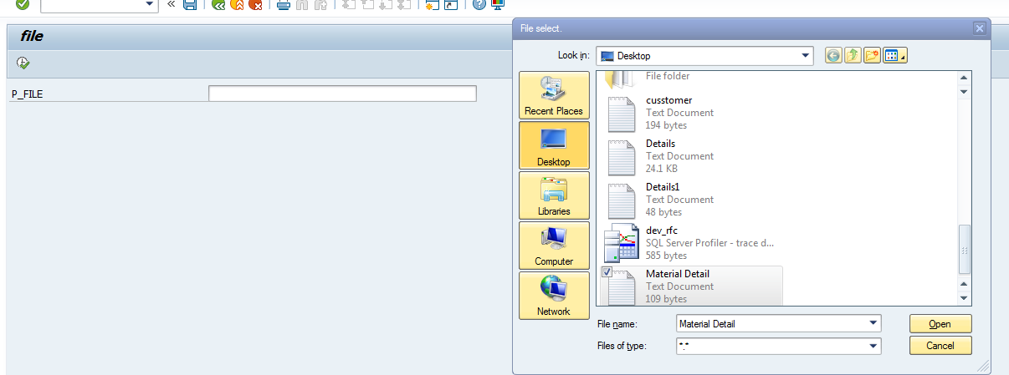

6)Click on execute and then Click on allow.

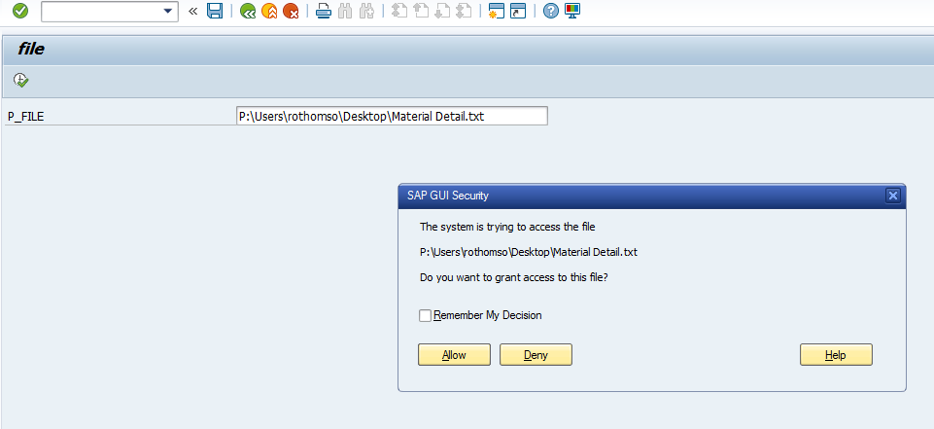

1. Go to tcode al11.Double click on DIR_HOME

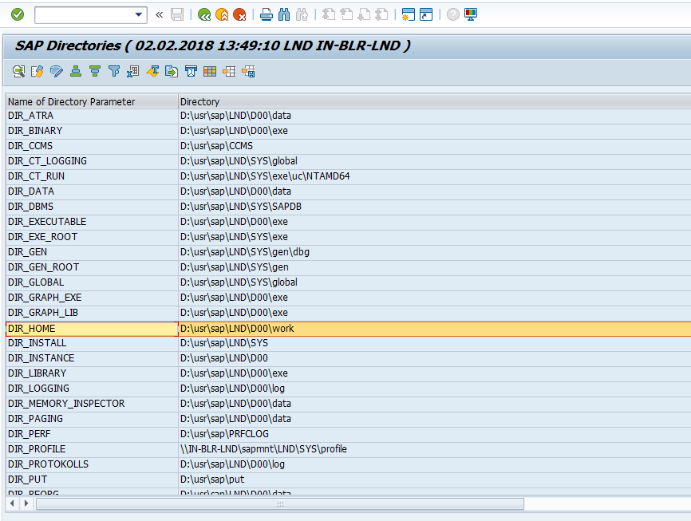

1. Locate your file ZRTC_FILE

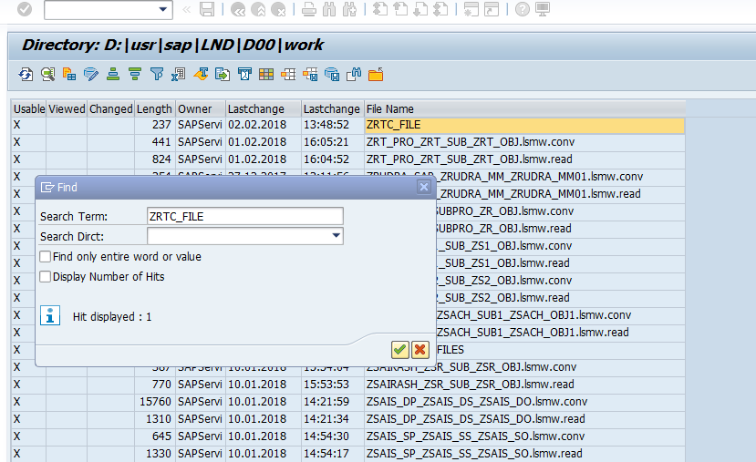

1. Double click on your file ZRTC_FILE.

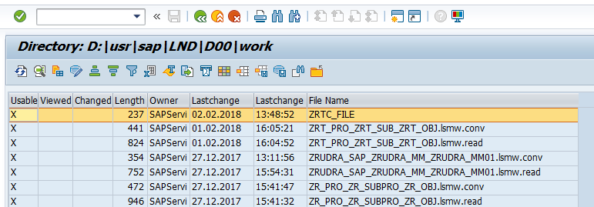

9)Output expected is as below.

This shows Material data is loaded into Application server

